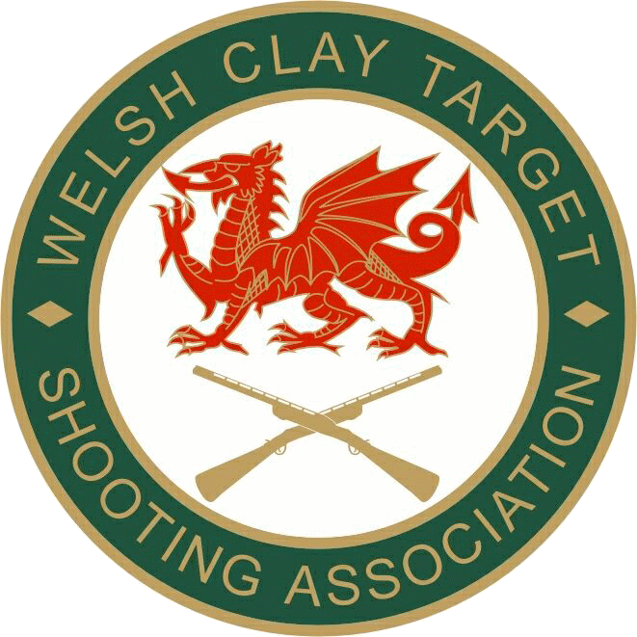

WCTSA County Competition Rules

Objectives of County Competition

To encourage the ‘Grass Roots’ shooters to participate at competition level.

General County Rules.

The following rules apply to ALL County Teams and for All County Disciplines.

- County Team Selection Procedure.
Due to the falling number of county shooters at recent WCTSA County events, and the absence of County Coordinators for many shooting disciplines, the outcome of a meeting held on November 20th, 2021, was to revamp the current format of Welsh County shooting.
- It was decided that for the 2022 season, County selection shoots would not be held to qualify to shoot for a Welsh County Team.
- Each of the WCTSA disciplines, (except for FITASC), will hold a Finals Day which will be arranged by the WCTSA Board Discipline Reps, with the All-Round discipline awarded by the Board.
- Where possible the venue for finals will be varied geographically each year.
- The Role of National Coordinator has been taken in house and is now part of the WCTSA Secretary’s duties.
- Shooters wishing to attend and shoot a County Final, must ring the host ground to register their entry NO LATER THAN ONE WEEK before the date of the final. Failure to do so will mean that you are not able to shoot the event
- When registering with the host ground, the shooter is required to supply a current WCTSA membership number, along with which COUNTY and CATEGORY they wish to shoot, and whether they are a new cap or not. The only exception to this will be for Olympic Trap and Olympic Skeet where the County does NOT need to be nominated due those finals having a slightly different format and being named as a ‘Welsh Championship’.
- Entry fees will be taken by the ground with the accompanying levy on the day of the final.
- Grounds holding County Finals will be required to use the CPSA ‘Shoot’ software for running the event, which is available from the WCTSA Secretary along with any training which may be required. Grounds must make sure they regularly update this program to ensure they are using the most up to date membership details and classifications.
- There will be an additional shoot off competition at the end of the day, except for Olympic Trap and Olympic Skeet due to their different format.
The Shooter with the highest scores from each county will shoot a round of their discipline, (Sporting 2 stands of 10 birds, All Round discipline to be drawn from a hat from the four constituents.
The winner will be awarded the ‘County Shoot off Overall winner’.

